Y var: I (mA), U (mV)

X var: R (ohm)

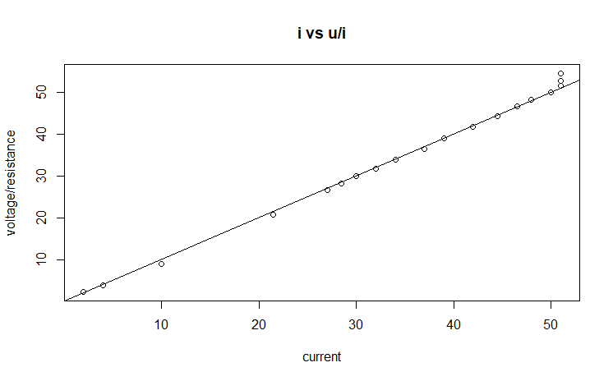

Plot of i=U/r

when current is low we observe that voltage/ resistance is low and gradually increases with current as it should be in accordance with physics laws. However 3 points in top right do not follow this pattern.

Plot after outlier removal

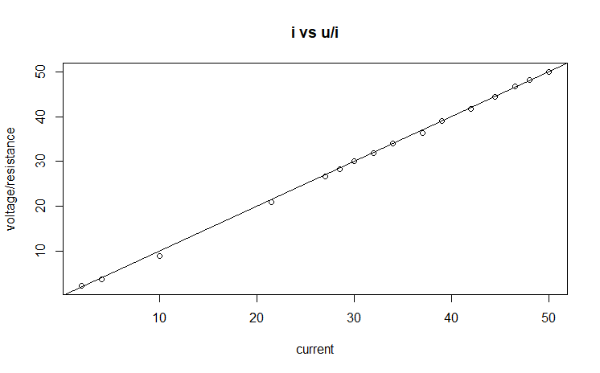

Task 2

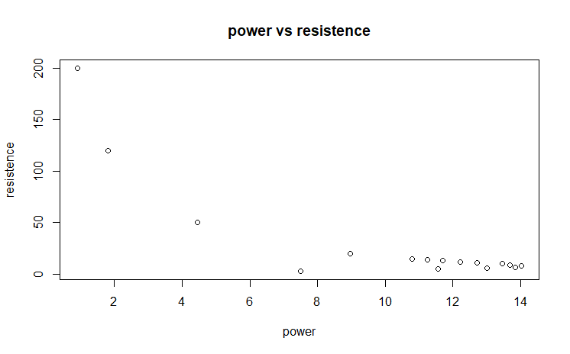

We can make an estimation that when power increases more than 6, very low resistence is observed. This can be marked as the nominal power requirements to switch the cell.

A closed loop control can be made possible for this arrangement by fixing input power to about 7 but a proper statement about it can only be made if we are provided with more information, as there are not a lot of points in the range of 6-8 to make a clear observation about this.

Summary of quadratic formula

lm(formula = photo$Power ~ photo$Resistence + I(photo$Resistence \*

photo$Resistence), data = photo)

Residuals:

Min 1Q Median 3Q Max

-5.4569 -0.4614 0.4425 1.1628 1.8795

Coefficients: Estimate Std. Error t value Pr(>|t|)

(Intercept) 13.4547029 0.7491758 17.959 1.47e-10 \*\*\*

photo$Resistence -0.1675111 0.0408065 -4.105 0.00124 \*\*

I(photo$Resistence \* photo$Resistence) 0.0005288 0.0002108 2.508 0.02618 \*

---

Signif. codes: 0 ‘\*\*\*’ 0.001 ‘\*\*’ 0.01 ‘\*’ 0.05 ‘.’ 0.1 ‘ ’ 1

Residual standard error: 1.977 on 13 degrees of freedom

Multiple R-squared: 0.8139, Adjusted R-squared: 0.7852

F-statistic: 28.42 on 2 and 13 DF, p-value: 1.794e-05

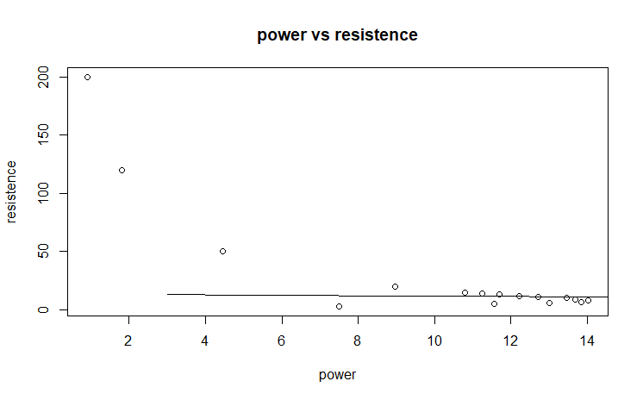

The model fits the functioning that we are trying to look for: that is switching on of the photovoltaic cell at increased power. As can be observed in the right bottom of the graph but still it does not correctly covers up the threshold value region that is from point 4-8.

TASK 4

plot(x^2 ~ x)

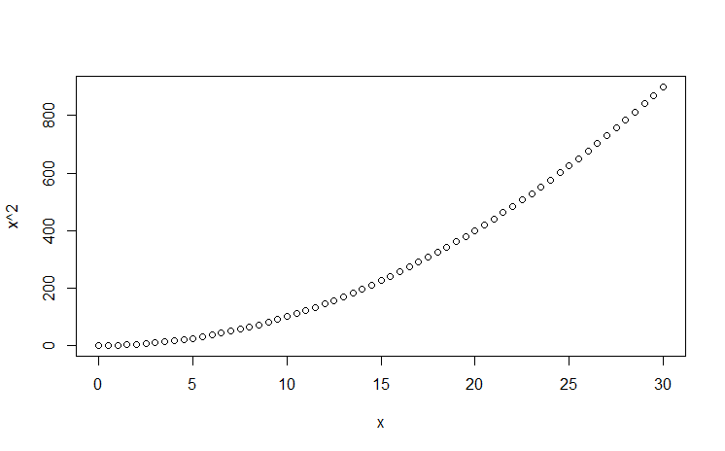

plot((x-15)^2\*(x>15) ~ x)

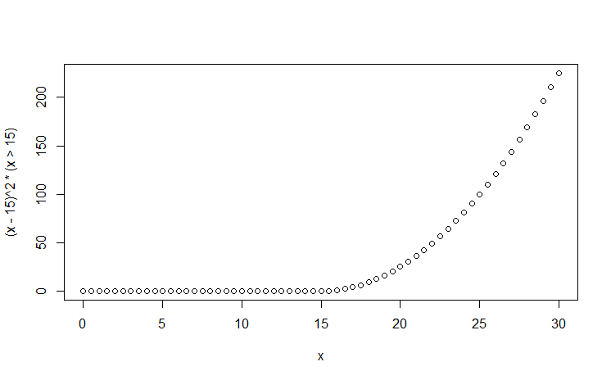

The curve becomes steeper and it becomes easier to approximate a value at which elevation is observed.

If we add a similar term it might be possible that we get a better picture of threshold vlue that can be set for a control loop to switch on photovoltaic cell.

We mentioned, improvement is observed and we can say that at 4 power is enough to switch the cell.

Task 5

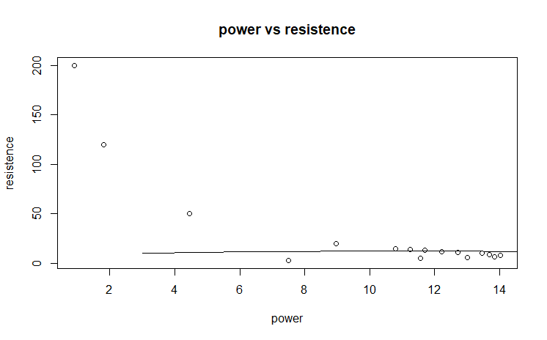

Task 6

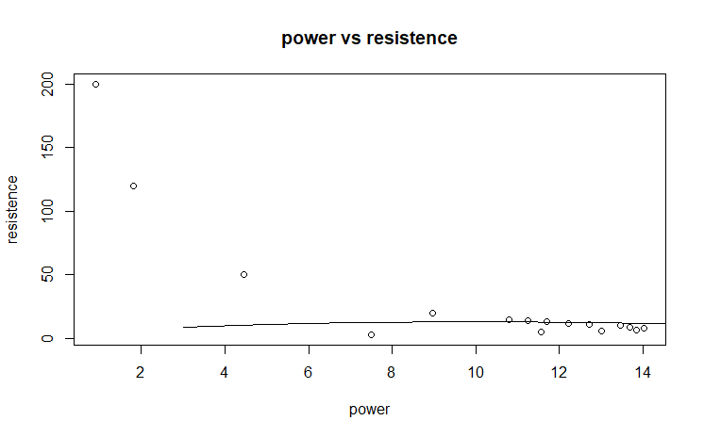

Apart from a little curvature in the line, I don’t observe any significant difference

Task 7

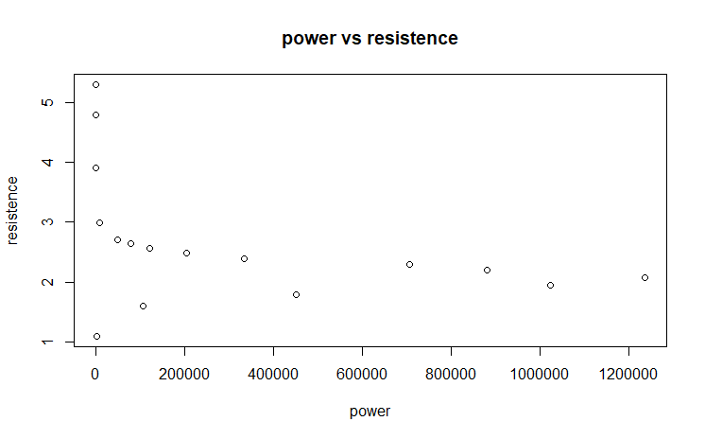

Task 8

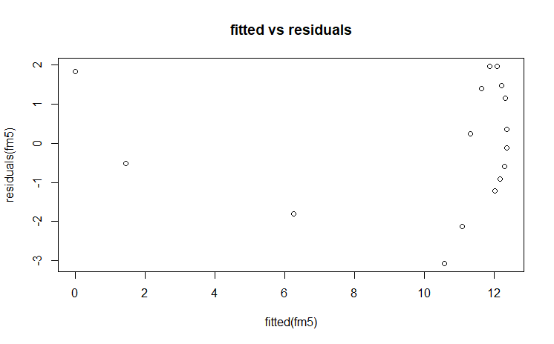

Trumpet like shaped is observed transformation of y variable is required.

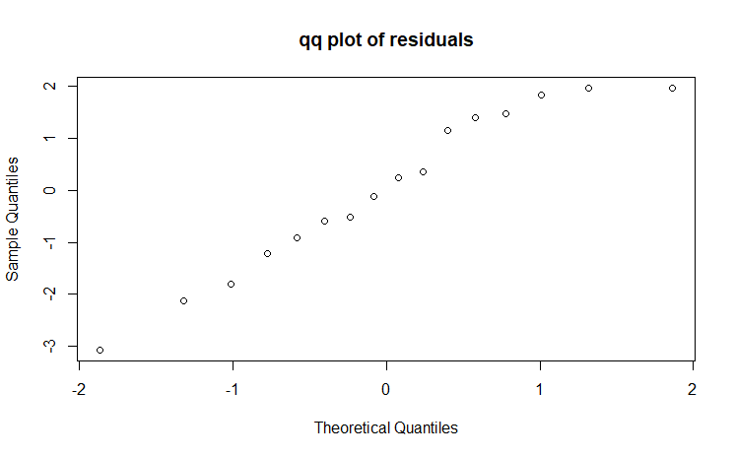

One outlier can be seen differed from the 45 degree line in the top right corner